PROJECT REPORT
Electronics Product Sales Data Analysis
Workflow, concepts, code and webpage
This project takes a raw US electronics sales file, cleans it, analyses it with Python (Pandas), draws charts with Matplotlib and Seaborn, and presents the results on an interactive webpage. It answers three questions: which products earn the most, which city buys the most, and when do customers order?
File | Purpose
Updated_sales.csv | Raw sales data (30,394 lines)
A5_B3_B4_SL_Project_.ipynb | Python notebook: cleaning, analysis, charts
summary_tables.xlsx | Three summary tables exported from the notebook
index.html + style.css | The presentation webpage
Webpage Link | https://electronics-salesdata.netlify.app/

1. Dataset
Each row is one product in one order. There are 6 columns: Order ID, Product, Quantity Ordered, Price Each, Order Date and Purchase Address. After cleaning there are 30,206 rows, 29,018 orders, 19 products and 9 US cities, mainly from April and August 2019.
The raw file had problems that had to be fixed before analysis:
- 87 blank rows and 61 repeated header rows mixed in with the data.
- 186 duplicate rows (this count includes repeats of the blank and header rows).
- Numbers stored as text, and two different date formats in one column.

2. Key concepts
Concept | Simple meaning
DataFrame | A table of rows and columns in Pandas, like an Excel sheet
Missing values / duplicates | Empty cells and repeated rows; they are removed so totals are not wrong
Data types | Text must be converted to numbers and dates (to_numeric, to_datetime) before calculating
New columns | Revenue = Price x Quantity; City, Hour and Month are taken from existing columns
groupby | Splits data into groups (such as city) and totals each group
Correlation | A number from -1 to +1 showing how strongly two columns move together
Mean vs median | Mean revenue per line is $186 but the median is $15, because a few expensive items pull the mean up

3. Workflow and code
Stage | What happens | Main code
1. Load and inspect | Read the CSV and check types, size and dates | pd.read_csv, info, describe
2. Clean | Fix blanks, duplicates and dates; save a clean file | fillna, drop_duplicates, to_datetime
3. Analyse | Create Revenue, filter, group, rank, export to Excel | groupby, nlargest, to_excel
4. Prepare for charts | Remove bad rows; add City and Hour | str.split, dt.hour
5. Visualise | 6 Matplotlib and 7 Seaborn charts | plt.plot, sns.heatmap
6. Web scraping | Read a table from a web page (not working) | requests, BeautifulSoup

Cleaning and Revenue are the two most important steps:
df = df.fillna(0) # fill empty cells
df = df.drop_duplicates() # remove repeated rows
df['Order Date'] = pd.to_datetime(df['Order Date'], format='mixed', errors='coerce')

df['Revenue'] = df['Price Each'] * df['Quantity Ordered']
Grouping and ranking gives the results used in the report:
product_rev = df.groupby('Product', as_index=False)['Revenue'].sum()
top10 = product_rev.nlargest(10, 'Revenue')
data['City'] = data['Purchase Address'].str.split(',').str[1].str.strip()
by_city = data.groupby('City')['Revenue'].sum().sort_values(ascending=False)
Charts. Matplotlib draws line, bar, horizontal bar, pie, histogram and scatter charts. Seaborn adds a histogram with curve, box plot, count plot, bar plot, two heatmaps and a pair plot. Each one follows the same pattern: create a figure, draw the chart, add a title and labels, then show it.

5. The webpage
The page uses only HTML, CSS and JavaScript, with no libraries. All charts are drawn by code.
Webpage Link:- https://electronics-salesdata.netlify.app/

- Header and hero: sticky navigation, a light/dark mode button and the title banner.
- Dataset: fact cards whose numbers count up when scrolled into view, plus a column table.
- Workflow: five clickable steps showing the description and code, with Previous, Next and Copy buttons.
- Try it: a revenue calculator where you choose a product and quantity to see Price x Quantity.
- Findings and charts: an animated bar chart, SVG line and pie charts, and a colour heatmap.
- Team: work-division cards and the list of tools used.
- style.css stores colours as variables, so dark mode just swaps one set of values. It uses Grid and Flexbox for layout, hover effects, and a 600 px rule for phones.
- JavaScript handles the theme button, the count-up numbers, the tabs, the calculator and chart drawing. Bar heights are value / maximum x 100 percent.
- The numbers on the page were copied from the notebook results, so they must be updated by hand if the data changes

4. Results
Measure | Value
Total revenue | $5,635,635
Total units sold | 33,969
Median revenue per line | $14.95
Top product | Macbook Pro Laptop ($1,280,100)
Top city | San Francisco ($1,355,726, about 24%)
Busiest hour | 7 PM (2,112 orders); quietest 3-4 AM
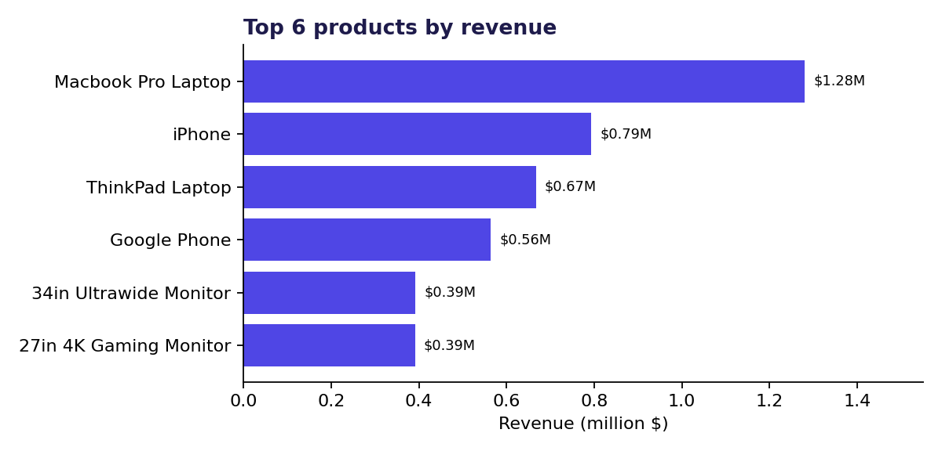
Figure 1. Laptops and phones earn the most revenue.
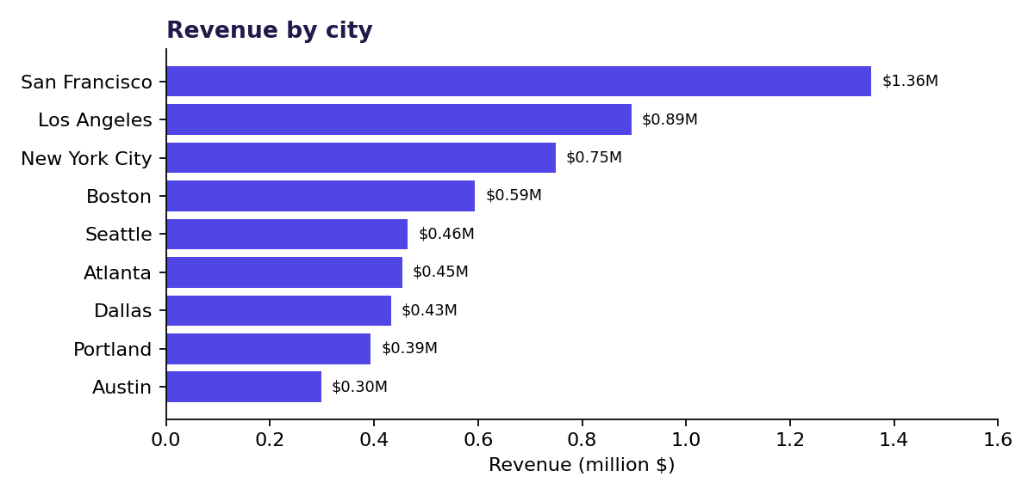
Figure 2. San Francisco, Los Angeles and New York lead.
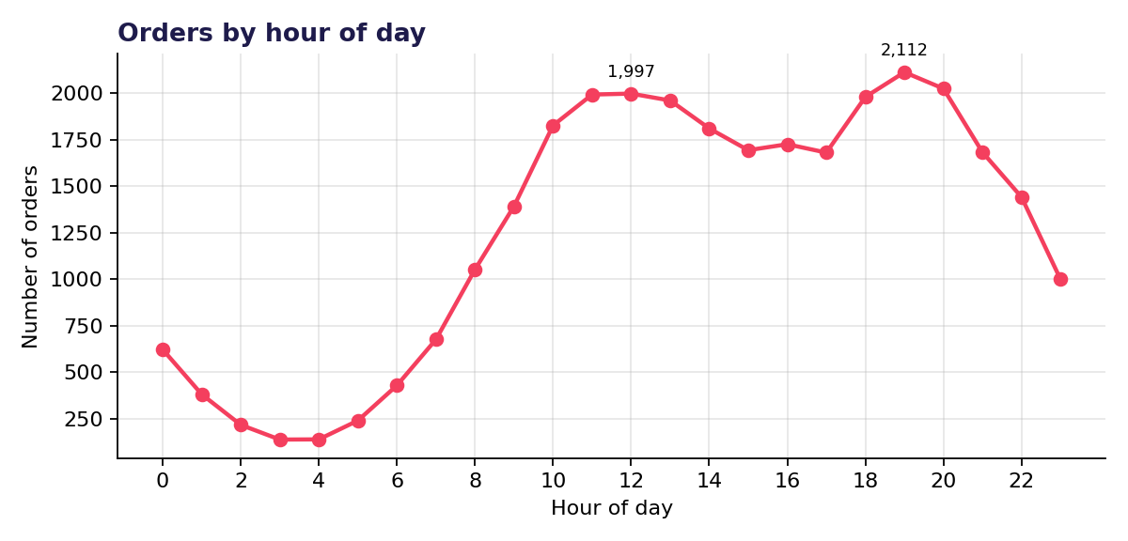
Figure 3. Orders peak around 12 PM and 7 PM.
What this means:
- Laptops and phones bring the most money, while batteries and cables sell the most units because they are cheap.
- Price and revenue are almost perfectly correlated (1.00); the hour of the day has no link with price or quantity.
- Promotions and support are best timed just before the midday and evening peaks.

6. Issues found and conclusion
Issue | Suggested fix
summary_tables.xlsx was made before duplicates were removed ($5,640,471 vs $5,635,635 clean) | Export from the cleaned data
fillna(0) creates 1970 dates and zero rows that are removed later | Use dropna() instead
Tiny May and September values (40 rows) look like mis-read dates | Check them and set the date format explicitly
The scraping cell has an unquoted URL, and Kaggle needs sign-in | Quote the URL; download the data instead
pip install cell is missing !; NumPy and SciPy are not used | Add !; use or remove the imports

Conclusion. The raw file was cleaned to 30,206 reliable rows, analysed with Pandas, visualised with Matplotlib and Seaborn, and presented on an interactive webpage. Laptops and phones drive revenue, cheap accessories drive unit sales, San Francisco is the strongest city, and customers order mostly at midday and around 7 PM.
Made by: A5-B4-66 Manav Lahoti, A5-39 Shrey, A5-57 Aayushka, A5-49 Disha
----------------------------------------------------------------------------------------------------------------------

